# Introduction to Problem Statement

Here we are going to design an integral part of an automotive system, that is, the Anti-Lock Braking System (ABS). We’ll be looking at executing a model designed as feedback system which depending wheel speed and the relative slip, the vehicle speed and stopping distance is calculated for.

The desired wheel speed considered here is 0.2 and a 4-wheeked vehicle is considered to decelerate from a particular speed to a standstill without wheel locking. The efficient of friction between tires and road is also considered which computes forth the break torque.

# Working and Analysis

The relative slip for the system is given by,

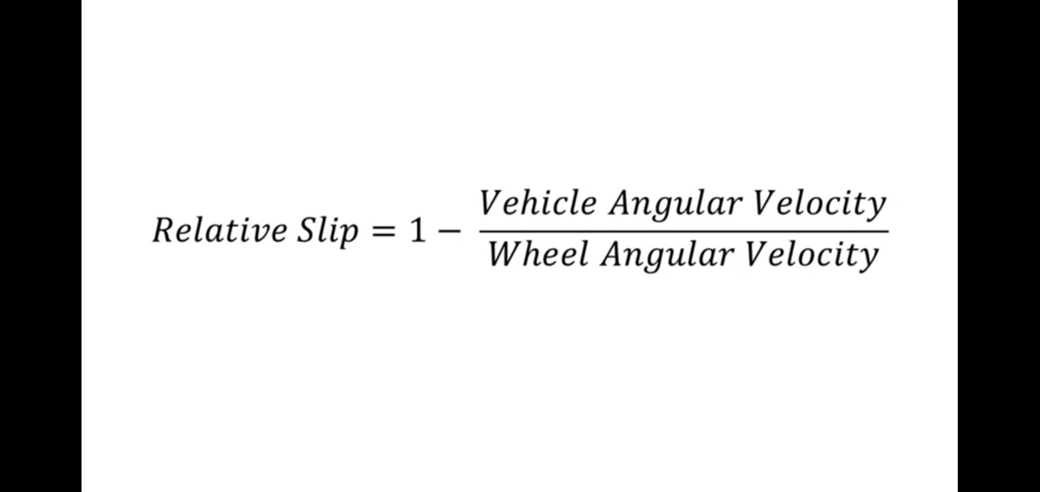

The tire Torque due to friction is given by,

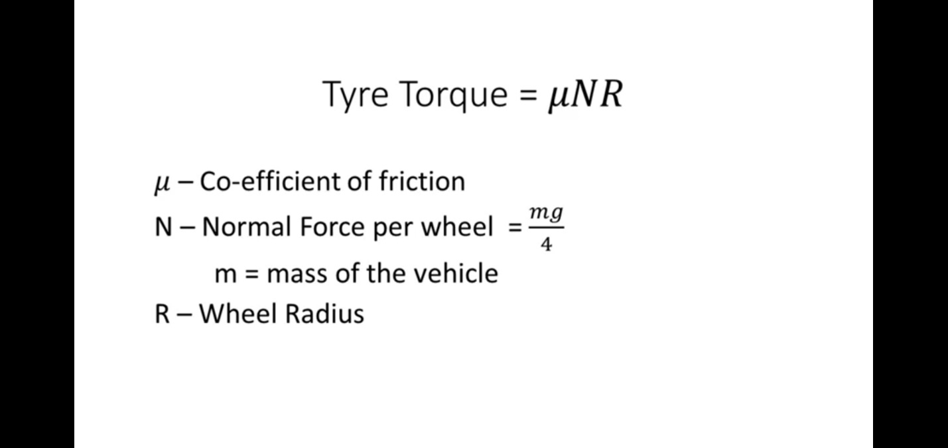

The vehicle speed for the system of operation can be calculated by considering the tyre torque, vehicle mass, and wheel radius and is given by,

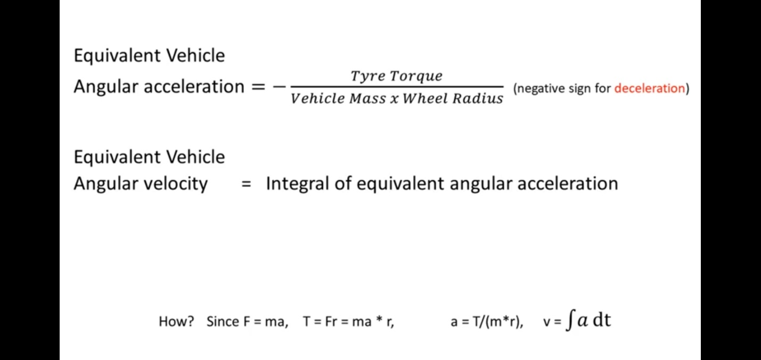

# Modeling

The difference between the desired slip and the relative slip will be used to compute forth the anti-lock braking mechanism. The relative vehicle slip is calculated by computing the vehicle speed and the wheel speed, and this is done by modeling the transfer function as shown below,

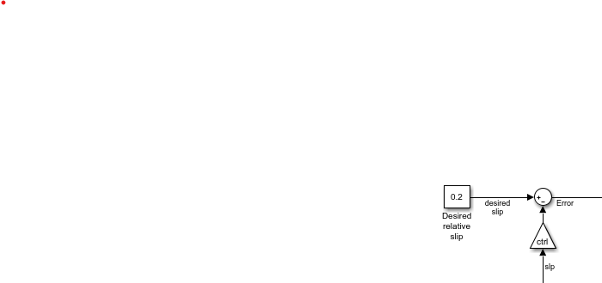

The control block is used to switch between ABS and no ABS.

For calculating the vehicle and the wheel speed we will be needing the coefficient of friction between the tire and the ground, and also the friction changes as the wheel slip changes and that is why we use a look up table to check the relative slip, outputting the coefficient of friction, as we can see from the expressions in the working, we give the gain blocks needed to give the frictional force and subsequently given as input for finding the wheel speed.

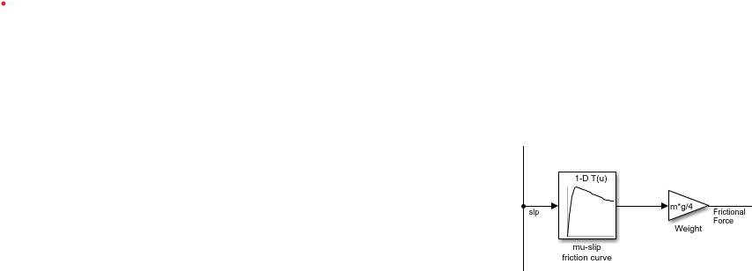

By finding the difference of desired slip and relative slip, we get the error which will be used to calculate the wheel speed of the system. This is done in a number of steps, the first is with using a bang-bang controller which a controller using relational operation and is given by,

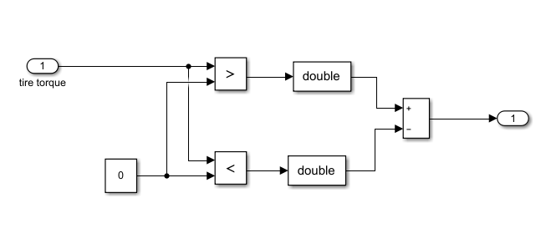

This is followed by asserting a hydraulic lag as transfer function and an integrator giving the breaking torque.

Now as stated before one of the inputs being from friction force and the other as the breaking torque to give the wheels speed and this is represented as a subsystem as shown below,

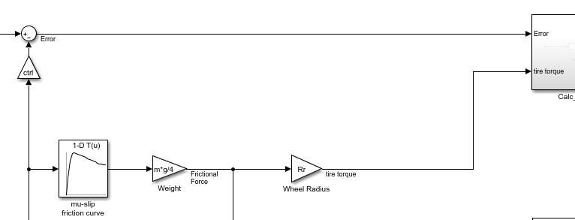

Thus, giving us the wheel speed,

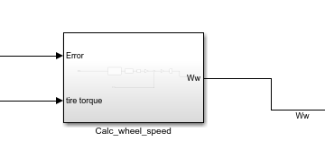

Wheel speed Subsystem

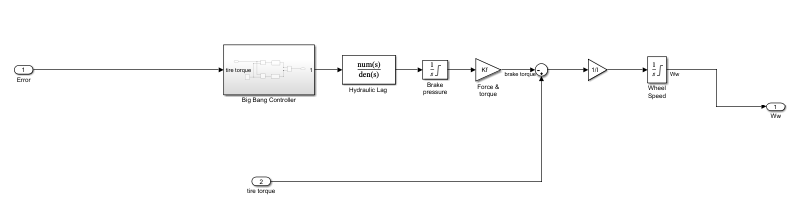

Wheel speed inside subsystem

Similarly using frictional force, we can find the vehicle speed and the stopping distance as shown below,

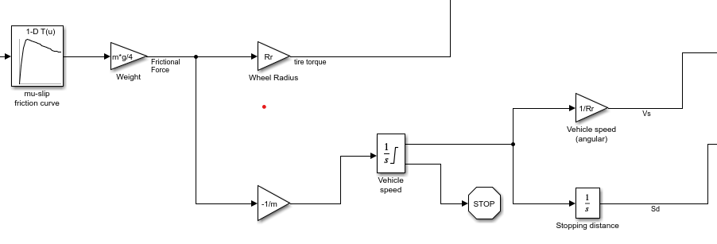

And finally, all of the outputs are given as input to to relative slip transfer function to give the final model as shown below.

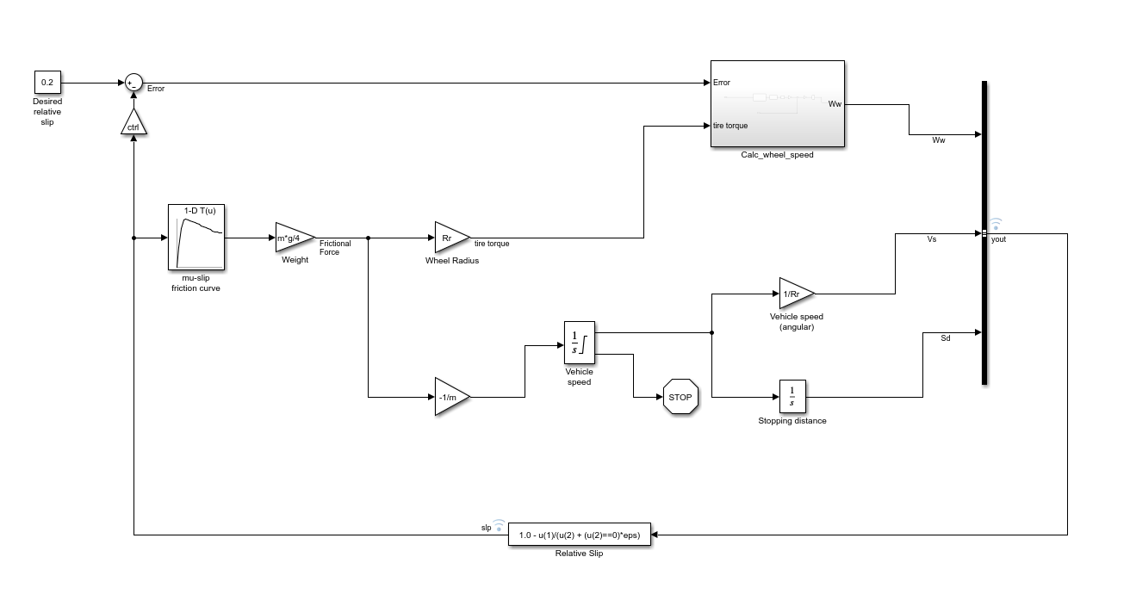

## Using of Functional block For Relative slip Transfer function.

The relative slip in the model is given by a MATLAB Functional model here, which are used for easy implementation of complex computations, and looking at the expression stated above it is implemented as seen in the model.

## Use of signal Generator

Multiple Signal generators can used for testing multiple inputs easily and it can be implemented as such easily.

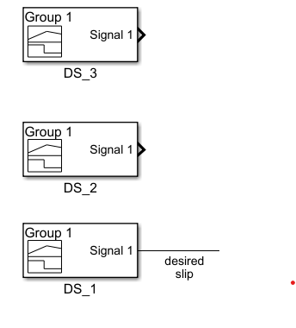

# FINAL Model

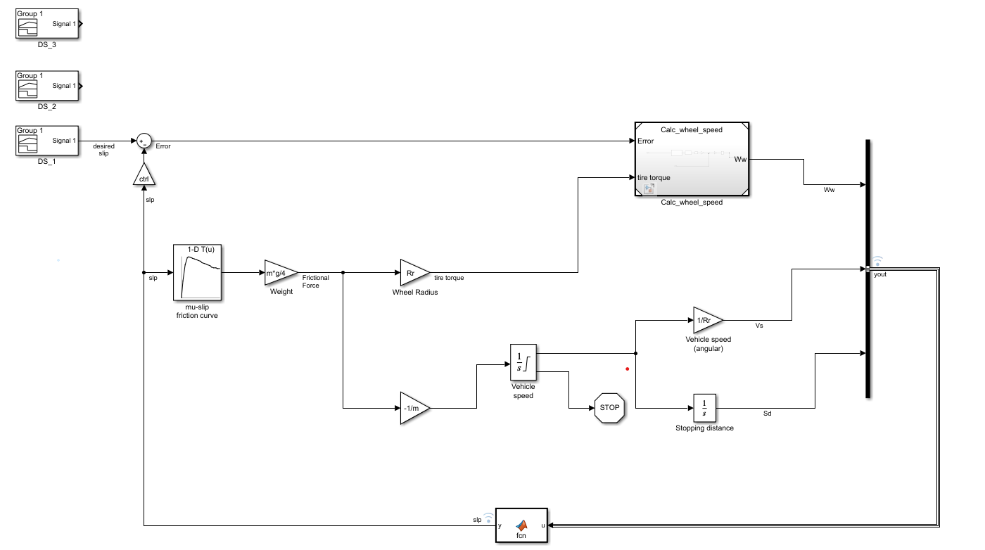

# Simulation with ABS

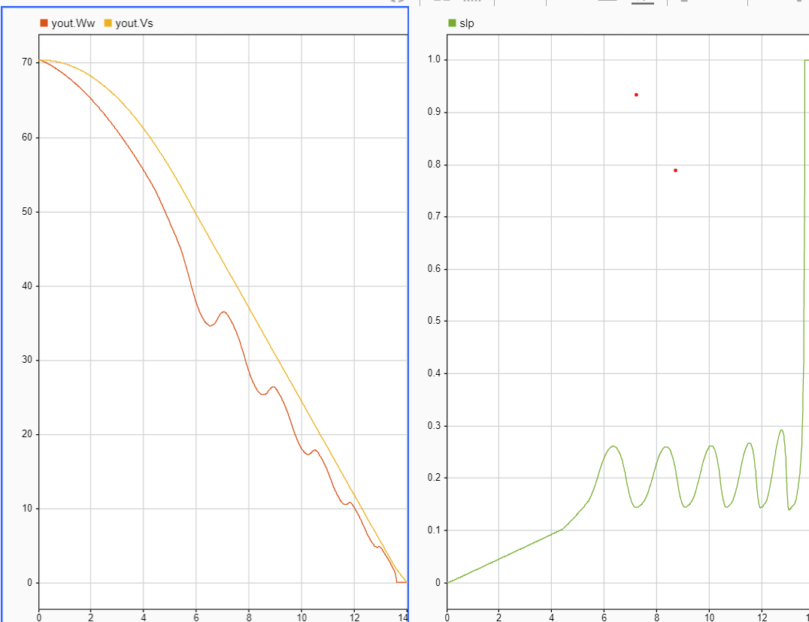

# Simulation without abs

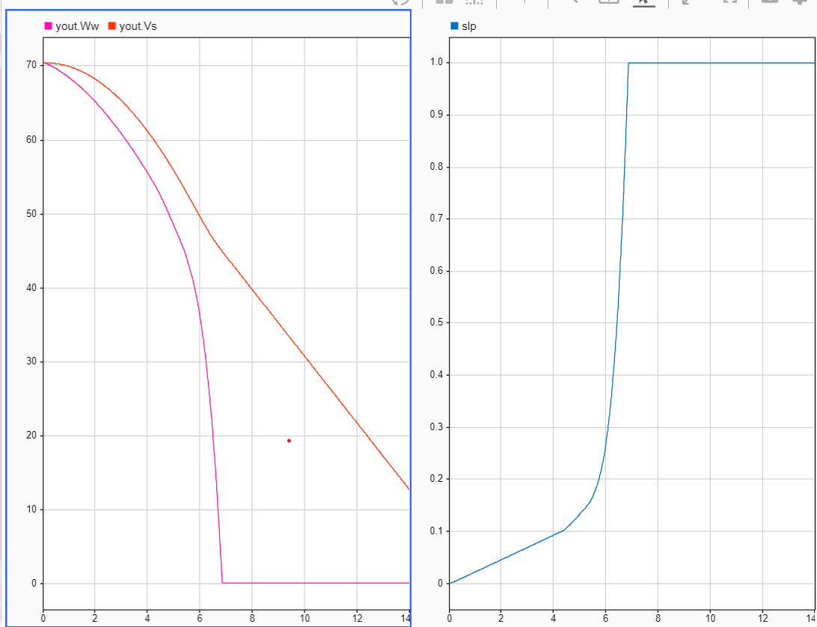 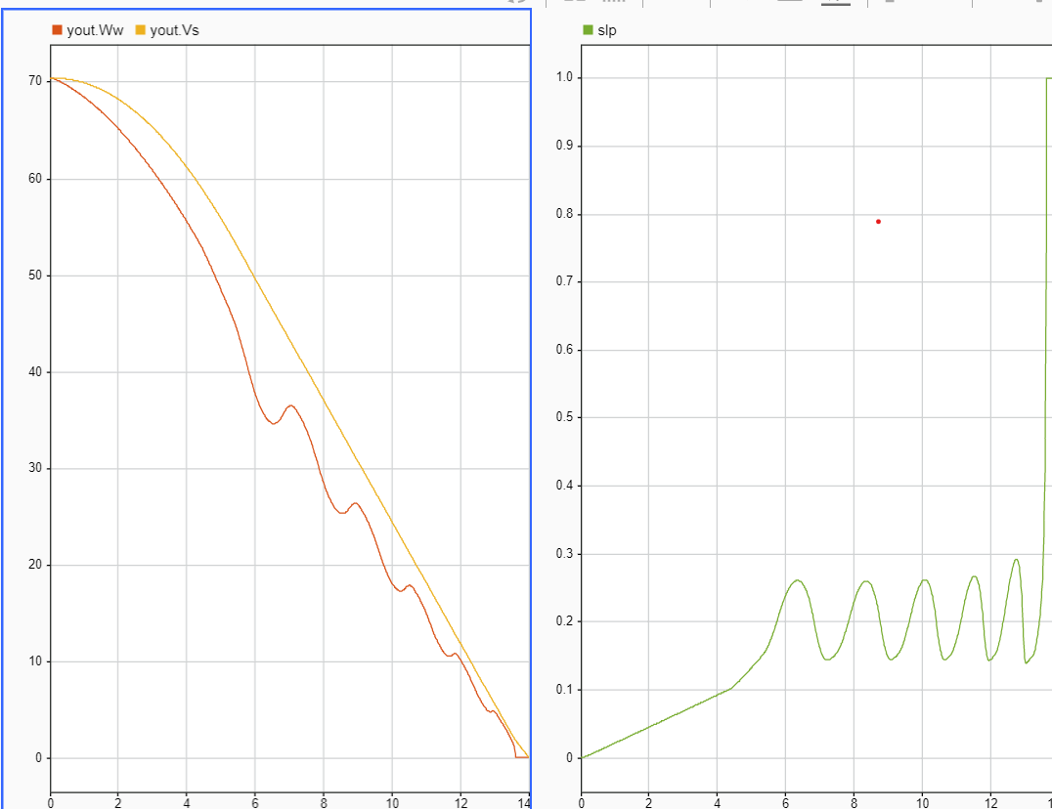

# Final Simulation

